Experiment: Implementation of Linear Regression (LR) Algorithm in Python
Aim
To implement the Linear Regression (LR) algorithm in Python and predict the output using a suitable dataset.
Theory
Linear Regression is a supervised machine learning algorithm used to predict a continuous numerical value. It establishes a linear relationship between an independent variable (X) and a dependent variable (Y).
The equation of Linear Regression is:
$$Y=mX+c$$
where:
- Y = Dependent variable
- X = Independent variable
- m = Slope of the line
- c = Intercept
Procedure
- Import the required Python libraries.
- Load a suitable dataset (Diabetes dataset).
- Split the dataset into training and testing sets.
- Create the Linear Regression model.
- Train the model using the training dataset.
- Predict the output for the testing dataset.
- Calculate the Mean Squared Error (MSE).
- Calculate the R² Score.
- Display the actual and predicted values.
Python Program
from sklearn.datasets import load_diabetes
from sklearn.model_selection import train_test_split
from sklearn.linear_model import LinearRegression
from sklearn.metrics import mean_squared_error, r2_score
# Load Diabetes Dataset
diabetes = load_diabetes()
X = diabetes.data
y = diabetes.target
# Split dataset into training and testing
X_train, X_test, y_train, y_test = train_test_split(
X, y, test_size=0.3, random_state=1
)
# Create Linear Regression model
model = LinearRegression()
# Train the model
model.fit(X_train, y_train)
# Predict
y_pred = model.predict(X_test)
# Evaluation
mse = mean_squared_error(y_test, y_pred)
r2 = r2_score(y_test, y_pred
# Display Results
print("Actual Values:")
print(y_test)
print("\nPredicted Values:")
print(y_pred)
print("\nMean Squared Error:", mse)
print("R2 Score:", r2)
Output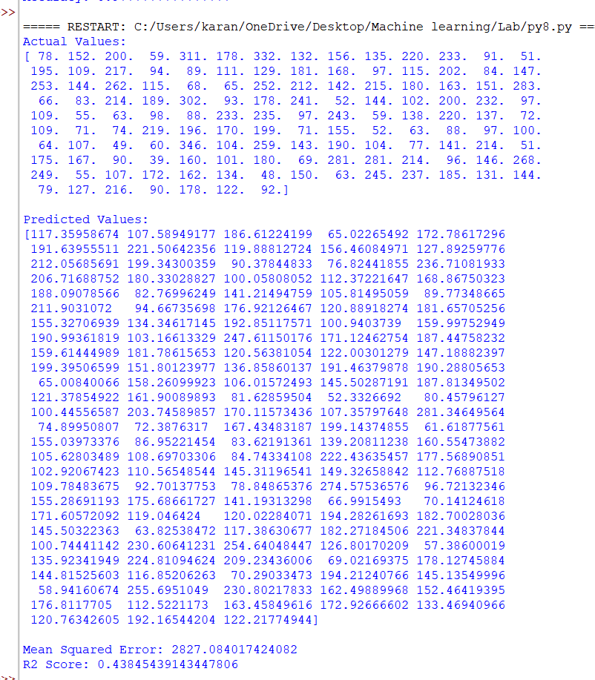

Result
The Linear Regression algorithm was successfully implemented in Python. The model was trained and tested using the Diabetes dataset. The performance was evaluated using the Mean Squared Error (MSE) and R² Score, and the predicted values were obtained successfully.

